New report makes business case for biophilic design in offices
‘Reap What You Sow: Valuing Workplaces that Grow Good Ideas’ is a collaboration between PLP Labs, Joyce Chan from Loughborough University, Professor Derek Clements-Croome from the University of Reading, and Benholm Group.
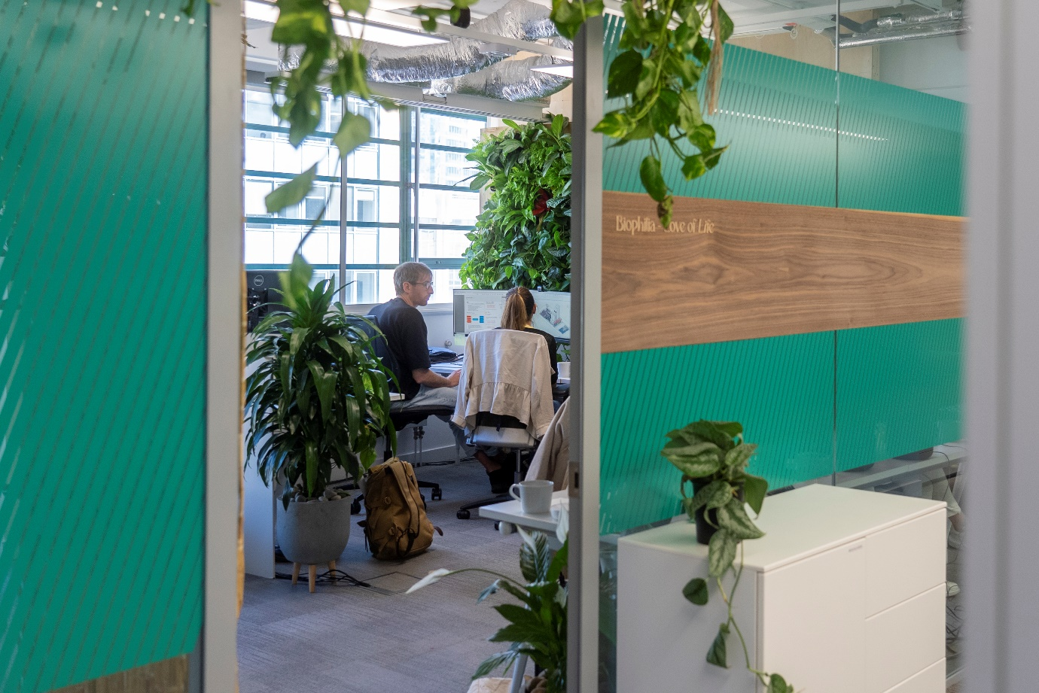
Please see more images and the full report here
- ‘Reap What You Sow: Valuing Workplaces that Grow Good Ideas’, a new publication by PLP Labs and its academic and industry partners, explains the process of measuring and monetising the well-being and environmental value of biophilic design in offices.
- This research helps designers and architects to make a business case for healthy and sustainable design decisions, which are often the first to suffer from value assessments.
- A financial proxy applied to data collected through sensors, wearables and interviews demonstrates up to a 200% uplift in well-being and environmental value in an office with greenery and views out.

‘Reap What You Sow: Valuing Workplaces that Grow Good Ideas’ is a new report by PLP Labs that explains the process of measuring and monetising the well-being and environmental value of biophilia in architectural design. In corporate real estate, the environment impacts the bottom line. PLP’s study – run in collaboration with academics from Loughborough University, the University of Reading, and plant experts Benholm enables real estate clients to fairly evaluate the worth of investing in nature alongside other project costs.
The report is the culmination of a year-long research project between PLP Labs and their research partners in both academia and industry that explores how to attribute monetary value to well-being and environmental quality in workplace design.
Biophilic design can take the form of green walls, pot plants, skylights, water features or wood furniture. These features add value to the workplace; not only through improving air quality and aesthetics, but also tangibly impacting on employee health, creativity, productivity and satisfaction. Given employees are the largest cost for a business, the report explores to what extent biophilic design can save companies money by ensuring that staff are healthier and happier at work.
The report also highlights the importance of integrating biophilia into the architectural design process early and earmarking investment for it, so that the mechanical, electrical, and plumbing of the building can accommodate the plant life. Plants affect building conditions like humidity and air flow, therefore these conditions need to be accounted for.
An eight-week pilot study was conducted in PLP Architecture’s London studio, where employees worked in three different environments with varying degrees of views out and indoor greenery. The study used both qualitative and quantitative means to monitor the participants' well-being and environmental quality during each scenario. Qualitative methods included questionnaires and interviews. Quantitative data on air quality, heart rate, steps, sleep quality, noise level, and EEG (brain waves) was collected through sensors and wearable technology.
A financial proxy was applied to the data collected from the post-occupancy evaluation, demonstrating the long-term value and potential of the well-being economy in monetary terms for stakeholders such as investors and developers.
Clear differences were found between the different degrees of biophilic workspace. The baseline scenario, with restricted views out and no indoor greenery, had the lowest net value of £11,627. The immersive scenario, with extensive views out and indoor greenery, was found to have the highest monetary gains in terms of well-being and environmental value, but also the highest capital investment, giving a net value of £16,830. The typical scenario, with moderate views out and indoor greenery found in a typical office set-up, had the largest net value of £22,211.
Measuring biophilic design in monetary terms enables designers and architects to make a business case for biophilic design, and enables investors, developers and occupiers to understand the long-term value and potential of the well-being economy. Not only this, the methodology used to measure the value of biophilic design can easily be translated to evaluate the value of other healthy and sustainable design choices.

Notes to editors
‘Reap What You Sow: Valuing Workplaces that Grow Good Ideas’ is the product of a collaboration between PLP Labs, academic partners Joyce Chan from Loughborough University and Professor Derek Clements-Croome from the University of Reading, and biophilic design experts Benholm Group, and with advice from biophilia specialist Alexander Bond.
This work continues PLP Labs’ explorations into healthy workplaces and expands on an earlier study for the British Council of Offices, with Joyce Chan and Professor Derek Clements-Croom on the use of wearables to monitor well-being in the office.

Please see more images and the full report here.

Authors of the Report
- Joyce Chan-Schoof: Main author, PhD Research Scholar at Loughborough University
- Professor Derek Clements-Croome: Contributing author, University of Reading
- Savannah Willits: Editor, PLP Labs Team Lead

Acknowledgements
Collaborator and indoor plants sponsor: Adrian Byne (Benholm Group) www.benholm.com
Loughborough University, Dr. Vicky Lofthouse & Dr. Robert Schmidt III (PhD supervisors of the Lead Investigator), School of Design and Creative Arts & School of Architecture, Building and Civil Engineering. Loughborough University.
British Council for Offices (BCO) financed an earlier pilot study on the use of wearables to collect meaningful data from office workers. This previous research informed the study on the measurement and value of biophilic design.
Biophilic Design, Alex Bond contributed to the early phase of design.

Groups Involved
PLP Labs
Is a design research collaborative operating at the intersection of technology, culture and space. We investigate possibilities and define solutions for tomorrow’s cities. We collaborate with leading experts from around the world and across a wide spectrum of disciplines to offer an expanded range of knowledge-based services.
www.plplabs.com
engage@plplabs.com

Benholm Group
An industry leader, Benholm Group has become a go-to resource for planting design that pushes the boundaries of creativity thanks to an experienced team that live the company culture of being creative, having a can-do attitude, and being caring.
www.benholm.com
Mail@benholm.com

Joyce Chan, Loughborough University
Joyce is a PhD Researcher at the Design School of Loughborough University. This case study is part of her doctoral field-study to develop a Valuing Biophilic Model to make a business case for human-centric design. She an Architect with two decades of experience in sustainable design; She is currently the Sustainability Lead of the UK Parliament’s Design Authority. She is passionate about bring research into practice.

Professor Derek Clements-Croome
Professor Clements-Croome is an Emeritus Professor in the School of The Built Environment at the University of Reading in Architectural Engineering research. His projects focus on the impact of wearables on office workers, and health and mental wellbeing in the workplace. Professor Derek Clements-Croome has co-authored numerous pieces reports and guidance.

